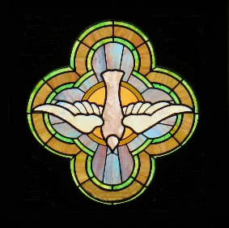

Fall, 2026 Worship Schedule
Unless otherwise noted, Worship will be held at Sanctuary on Ridge
1638 Ridge Rd, Ontario, NY @ 10 am.
“Sacred Sips” are available before, during, and after worship.
Build community—invite a friend.

Sunday, Sept. 20 @ 10 am. Worship and Communion led by Rev. Dr. Betsey Crimmins. We will celebrate community, our connections, and our new website during and after worship. Come, taste and see!

Tuesday, Sept. 29, 7 - 9 pm, Tentative Spiritual Growth Opportunity: GRATEFUL AGING webinar and discussion from Gratefulness.Org. Contact Jane Smith if interested.

Sunday, Oct. 4 @ 10 am. Worship and World-Wide Communion service led by Rev. Dr. Betsey Crimmins. Music offered by Rachel Dobbs. Location: Trimble home, 7695 Tamarack Lane, Ontario. PCUSA Peacemaking offering collected.

Sunday, Oct. 18 @ 10 am. Worship led by Pat Chakalis with music offered by Rachel Dobbs.

Sunday, Nov 1 @ 10 am. Worship and Communion led by Rev. Dr. Betsey Crimmins. Music offered by Rachel Dobbs.

Sunday November 15 @ 10 am. Labyrinth walk incorporated into worship. Led by the Worship Team. Finger labyrinths available for those who prefer. If you have a finger labyrinth, please bring it!

Sunday, November 15, noon- 1:30 pm. Labyrinth open for reflective walking.

An Advent worship service will be Sunday, December 6.
Sunday December 20, we will share in a time of singing Christmas carols.

09/01/26

